Parallel Implementation of an algorithm for computing translocation
distance between genomes

Kenneth Chin, Seh Leng Lim, Jatin Shah

Introduction

The aim of our project is to parallelise the algorithm by Sridhar Hannenhalli
for computing the evolution of one genome to another by translocation.

What is a translocation ?

Translocation is a rearrangement event which exchanges genetic
material between two chromosomes. A translocation on a pair of chromosomes of genome A transform genome A into
another genome.k
There are two types of translocation events :
Prefix-prefix translocation and Prefix-suffix translocation. They are shown in
figure 1 below.
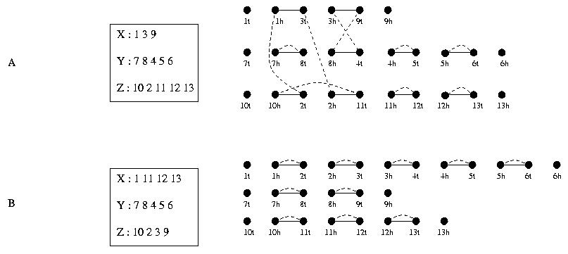
Data Modelling

In our program, each gene is represented by a data structure that has a name
field in integer. As each chromosome is made up of a sequence of genes, it is
represented by a data structure that contains a pointer to a linked list of
the gene data structure. As each genome is made up of a sequence of
chromosomes, it is represented by a data structure that contains a pointer to
linked list of the chromosome data structure. Figure 2 below illustrates the
data structure of the gene, chromosome and the genome.

typedef struct gene_t {
int name;
subgene left;
subgene right;
struct gene_t *prev; // black edge;
struct gene_t *next; // black edge;
} gene;

typedef struct chromosome_t {
int name;
gene *g;
struct chromosome_t *prev;
struct chromosome_t *next;
} chromosome;

typedef struct genome_t {
int name;
int nchromo;
int ngene;
chromosome *c;
} genome;

Parallel Implementation

Two approaches are being considered :
Distributed Memory Model and Shared Memory Model

The distributed memory model is not suitable because of its communication overhead. As the cleavage point in a chromosome may occur anywhere

